ABSTRACT

This project seeks to evaluate the impact and effectiveness of a recent public health awareness campaign aimed at addressing a pressing health issue. In an era marked by global health challenges, effective communication and outreach are vital components of public health initiatives. The campaign under scrutiny focuses on raising awareness about a specific health concern, employing various media channels and strategies.

INTRODUCTION :

Welcome to our Public Health Awareness Campaign! Our mission is to spread knowledge, inspire action, and foster a healthier, more resilient society. Throughout this campaign, we will tackle pressing health issues, promote preventive measures, and empower individuals to make informed choices for their well-being. Together, we can create a brighter, healthier future for our communities and beyond. Join us in making a difference!

Analyzing a public health awareness campaign involves steps:

1.Campaign Goals and Objectives:

Start by identifying the campaign’s goals and objectives. What was the intended outcome of the campaign? Did it aim to raise awareness, change behavior, or achieve specific health-related outcomes?

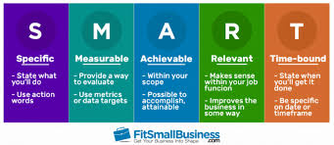

2.Target Audience:

Determine the campaign’s target audience. Who was the campaign trying to reach? Understanding the demographics, behaviors, and needs of the target audience is crucial.

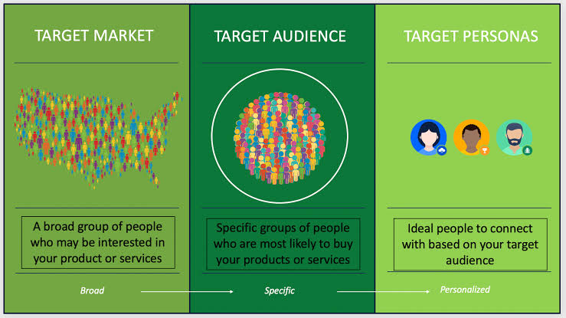

3.Messaging and Content:

Evaluate the messaging and content of the campaign. Was it clear, persuasive, and culturally sensitive? Did it use various communication channels (e.g., social media, TV, print) effectively?



4.Reach and Exposure:

Assess the reach and exposure of the campaign. How many people were exposed to the campaign messages? Was it distributed through appropriate channels to reach the intended audience?

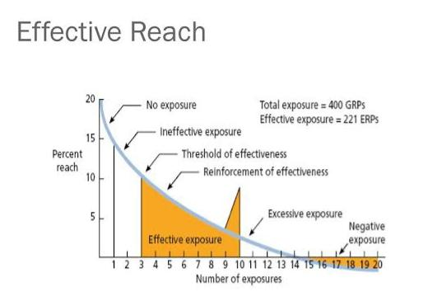

5.Impact and Behavior Change:

Analyze the impact of the campaign on the target audience. Did it lead to desired behavior changes or increased awareness? Use data, surveys, or studies to measure this.

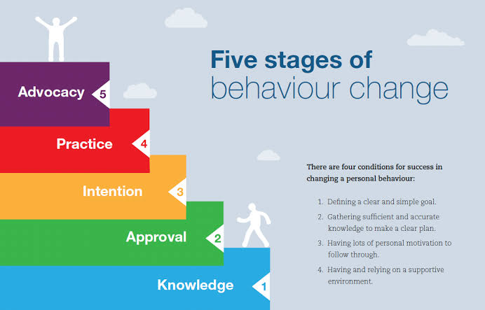

6.Cost-effectiveness:

Consider the cost-effectiveness of the campaign. How much did it cost to run, and was the investment justified by the results achieved?

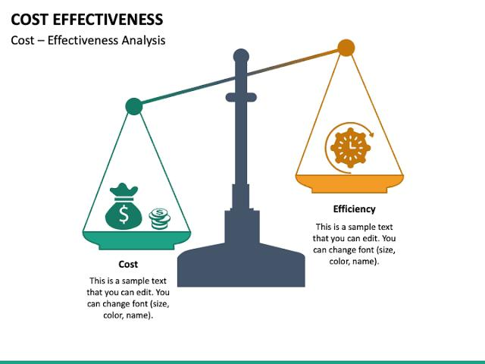

7.Long-term Effects:

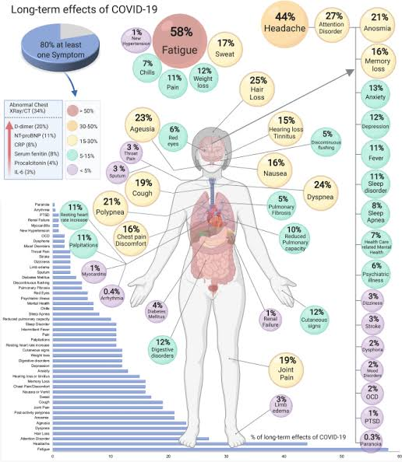 Investigate the long-term effects of the campaign. Did behavior changes persist over time, or was there a need for follow-up campaigns?

FEEDBACK:

Feedback and Evaluation: Gather feedback from the target audience and stakeholders. Were there any concerns or criticisms, and how were they addressed? Did the campaign evolve based on feedback?

CONCLUSION:

Remember that conducting surveys, collecting data, and consulting experts may be necessary for a thorough analysis. The success of a public health awareness campaign can have a significant impact on public health outcomes, so a comprehensive analysis is essential for informed decision-making